ACAT-Review-Guide – Ein tätigkeitstheoretischer Blick
auf die Beurteilung von Mathematik-Apps

Heiko Etzold & Ulrich Kortenkamp, Universität Potsdam
Silke Ladel, Pädagogische Hochschule Schwäbisch Gmünd
Kevin Larkin, Griffith University

Introduction
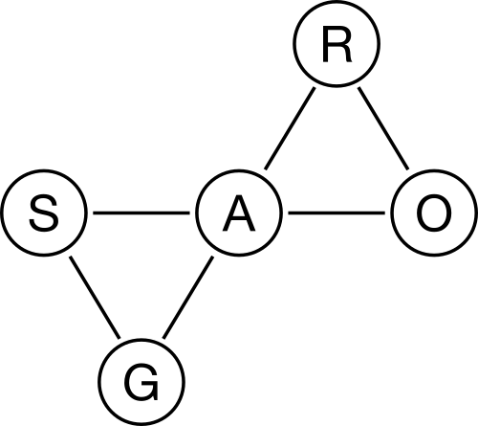
Mathematics education as a Design Science (Wittmann 1995) has the responsibility to help judge and review material for teaching and learning mathematics, including digital ones like computer software and apps for mobile devices. This review guide has been developed to fulfill that responsibility. The usual approach to evaluating the suitability of apps for teaching and learning are catalogues and categorizations, resulting in rankings (cf. Highfield & Goodwin, 2013). However, these are not particularly useful to give hints about the suitability of the app for a certain subject matter or particular classroom situation. We propose another approach, a theory-guided approach to evaluating Apps, without ranking them or even labeling them as “good” or “bad”, but as a guideline to find ways to judge the deployment of specific apps in the classroom.
The theoretical basis for our review guide is activity theory, more specifically the ACAT model (Artifact Centric Activity Theory, see Ladel & Kortenkamp, 2014). This model describes network of a subject (usually a student), an object (the mathematical subject matter), the mediating artifact (in our case an App used by the student to work with the mathematical content), as well as rules (describing how the app should behave based on the mathematical object) and the group (the whole classroom situation).
It is not necessary to know the details of the psychological and pedagogical theory in order to understand and use the following guide. A helpful introduction for those who want to know more can be the text of Kaptelinin (2014). For every step of the guide we will give background information concerning the theoretical foundation.

cba
This material is licensed under the Creative Commons License: “Attribution- ShareAlike 4.0 International“. To see a copy of this license, please visit http://creativecommons.org/licenses/by-sa/4.0/.

The Review Guide
This review guide is organized into five steps that can be associated to five foci in the ACAT model. It is mandatory to follow these steps in the given order.
Starting from the mathematical content we will analyze how students work with the app. From that we will infer whether the app is able to help in supporting the acquisition of the desired content. Finally concrete classroom situations can be discussed that are suitable for using the app. Based on this approach it can happen that the same app is perfectly suited for specific teaching situations, but not for others, even if the same topic is being handled. The step-by-step approach will guide the review to the essential and fundamental questions immediately. This can cause an early conclusion of the review after each step, if it is foreseeable that the app is not suitable for the planned instruction.
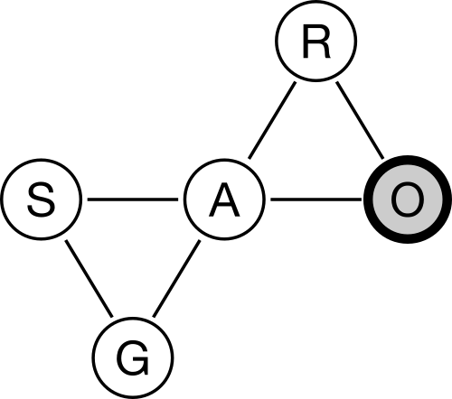
Thus, the review guide structures the decision process and makes it transparent to teachers. For every step we list the possible data sources that can be used.

Step 1: What is the mathematical object of the app?
Identify the mathematical object i.e. which concept, content or mathematics process is targeted by the app.
It is important to note that each app can address one or several mathematical objects. In the case of several objects, separate reviews for each object are necessary as each object will emphasize different learning facets and will therefore vary in efficacy across this range of facets.

Possible Sources
- The app’s title and its official description at iTunes or Google Play
- Additional material provided (e.g. downloadable worksheets)
- External references (e.g. recommendations by peers who have used the app)
- Trials of the app

Background
A central principle of activity theory is object orientation. As actions only exist (or at least can only be recognized) in relation to a specific object, activities are therefore directed towards the attainment of an object. Consequently, actions of students within an app can only be understood if the (mathematical) object of their actions is known. In this instance, the mathematical object is understanding how shapes can be manipulated to create new shapes.

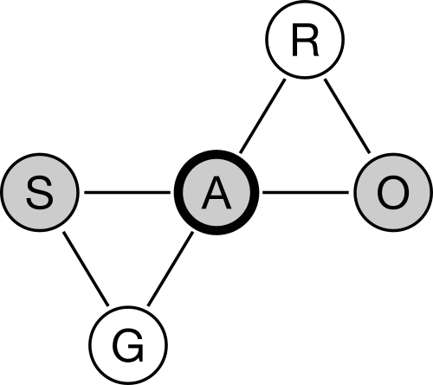
Step 2: How do students interact with the mathematical object, mediated by the app?
Discuss what kind of interaction with the mathematical object the app offers to the students. For this, it is necessary to look at the separate interactions between subject and artifact, as well as between artifact and object. In examining these interactions we can ask: What actions does the app support? How does the app represent the mathematical object? How does the object influence the “behavior” of the app? What can students experience through the above?

Possible Sources
- Own systematic testing of the app

Background
When designing an app, formulating the rules for user interaction would occur at this stage in the ACAT design process. As we are analyzing an existing app we immediately examine user interaction.
A core component of interest Activity Theory, and thus ACAT, is the process of Internalization and Externalization. External actions of the subject, such as pinch-to-zoom gestures to scale a city map represent internal actions, in this case dilations, that in turn are representations of student understanding. In a similar way, external actions can create internal representations. In order to understand this user interaction more fully, and to refer more concisely to the mathematical object, it is useful to sub-divide this process between subject and object at their respective interactions with the artifact (Ladel & Kortenkamp, 2014).
The guiding questions thus follow back and forth between subject, artifact, object:
S → A: Which actions does the app support?
A → O: How does the app represent the mathematical object?
O → A: How does the object influence the “behavior” of the app?
A → S: What can students experience through the above?

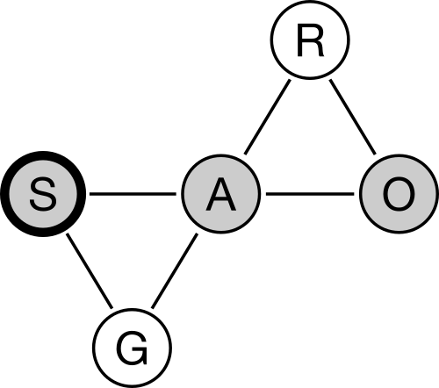
Step 3: How does the interaction develop?
Structure the possible interactions by categorizing them into activities, actions, and operations (Leontiev, 1981):
- Activities are superordinate interactions directed by the subject’s motives, e.g. reading a city map to determine direction of travel;
- Actions are targeted, individual interactions, e.g. changing a map’s scale to get a more detail view of a certain section of a map; and
- Operations are internalized interactions that do not need further cogitation and can be governed by instrumental constraints, e.g. the actual execution of pinch-to-zoom gesture to scale or of the drag gesture to move the map.
Elaborate upon how this categorization changes while using the app as actions can become operations during the learning process and allow for the creation of new actions in turn.

Possible Sources
- Discussion of hypothetical scenarios
- Empirical tests

Background
At this point in the review process a specific view on the hierarchy of activities, actions and operations as another principle of activity theory is appropriate. At the same time, conclusions about possible developments of students’ learning can be drawn. A successful learning process is characterized by actions becoming operations in order to enable more complex actions.

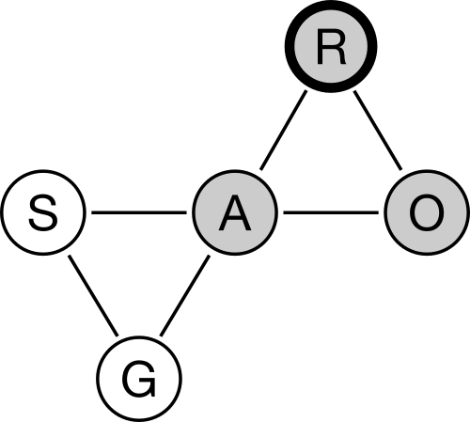
Step 4: Is the app suitable for teaching and learning the mathematical object?
Compare the use of the app for the specific mathematical object, as uncovered in the guide, with knowledge from mathematics specific pedagogy, the discipline of mathematics, and psychology regarding the teaching and learning of the mathematics object in question. In other words, do the interactions identified and analyzed in Steps 2 and 3 support the desired ideas, experiences, conceptions, and competencies, as required by quality mathematics education? In addition, is the technological design suitable for learning according to theories of high quality Human Computer Interaction (HCI) design?

Possible sources
- Syntheses of the discussion above
- Scientific background literature and references

Background
The design of an app is guided by rules in the ACAT model, which in turn are guided by knowledge from mathematics education, HCI design, etc. This ensures that the app is indeed supporting student learning, and that the targeted mathematical content can be taught or learned via its use.

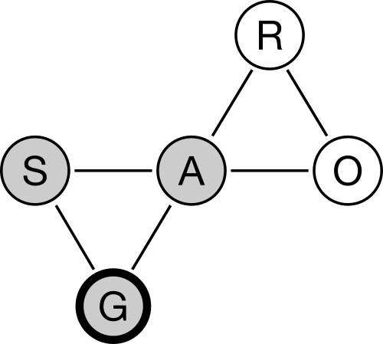
Step 5: How can the app be used in classroom instruction?
Illustrate how the app might be used in the classroom. You can use the following questions as a guide:
- Can the app be used for individual, partner or small group work or is it limited to only one of these types of social interaction?
- What are possible provocations or tasks the teacher can provide students?
- Which kinds of differentiation, and which levels of difficulty, are possible?
- Is it an app for instructive (drill and practice) activities or is it discovery based and designed to introduce students to new content or to construct new ideas?
- Which requirements and competences are necessary to use the app?

Possible sources
- Additional teacher’s material
- Trials with students
- Imagination

Background
Within both Activity Theory and ACAT, learning is never understandable as a pure individual activity of a student. It must always be seen in a social and corporate context where learning is common work. As noted by Giest and Lompscher (2004), in the classroom there is always a “pädagogisches Gesamtsubjekt” such that the activities always occur in the contexts of interaction, communication or cooperation, including relationships between learners, teachers, and other participants.

References
Giest, H. & Lompscher, J. (2004). Tätigkeitstheoretische Überlegungen zu einer neuen Lernkultur. In: Sitzungsberichte der Leibniz-Sozietät 72, pp. 101 - 123.
Highfield, K. & Goodwin, K. (2013). Apps for mathematics learning: A review of ‘Educational’ Apps from the iTunes App Store. Paper presented at the Mathematics education: Yesterday, today and tomorrow (Proceedings of the 36th annual conference of the Mathematics Education Research Group of Australasia), Melbourne, VIC.
Kaptelinin, V. (2014). Activity Theory. In: Armin Zahirovic et al. (Eds.), The Encyclopedia of Human-Computer Interaction, 2nd edition. The Interaction Design Foundation.
Ladel, Silke und Ulrich Kortenkamp (2014). Tätigkeitsorientiert zu einem flexiblen Verständnis von Stellenwerten – Ein Ansatz aus Sicht der Artefact-Centric Activity Theory. In: Von Audiopodcast bis Zahlensinn. Silke Ladel and Christoph Schreiber (Eds.), vol. 2. Lernen, Lehren und Forschen mit digitalen Medien. Münster: WTM Verlag, pp. 151 - 176.
Leontiev, A. N. (1981). The Problem of Activity in Psychology. In J. V. Wertsch (Ed.), The Concept of Activity in Soviet Psychology (pp. 37 - 71). New York: M.E. Sharpe.
Wittmann, E.C. (1995). Mathematics Education as a ‘Design Science’. In: Educational Studies in Mathematics 29, pp. 355 - 374.

